Breeding success of two tropical seabirds in the Seychelles
April J. Burt^{1, *} Fernando Cagua^{1,2} Cheryl Sanchez ³ , Melinda Curran?⁴, Janske van de Crommenacker⁵, Arjan De Groene?⁶, Cousine person?⁷ Nancy Bunbury¹
¹Seychelles Islands Foundation, P.O. Box 853, Victoria, Mahé, Seychelles
²University affiliation
³Nature Seychelles, Centre for Environment & Education, Roche Caiman, P.O. Box 1310, Mahe, Seychelles
⁴ Island Conservation Society
⁵Frigate Island Private
⁶ Green Islands Foundation
⁷Cousine Island Private

Abstract (~200 words)
In an effort to identify trends in breeding success and test the value of the data within a seabird hotspot region we combined monitoring efforts from six of the region's most vital nesting sites for tropicbirds. Tropicbird breeding success varied greatly between the sites. At Aldabra on average, for both species, 15% of nests were successful with most of the unsuccessful nests (70-75%) failing before hatching occurred. Breeding success was higher in the inner granitic islands and a lower proportion of nesting attempts fail at egg stage. On Aldabra, Aride and Cousin nest success rates for WT have been stable over the study period but the success rate for RT (Aldabra only) has changed markedly over time. At Aldabra the abundance of RT nests shows a negative trend and has been in constant decline since 2010. Contrastingly the abundance of WT nests has been stable and does not show any significant temporal trend. The Aride island WT population nest abundance showed a continuous negative trend since 2011. This study highlight that great amounts of data are being collected across the Seychelles, although there is some disparity between methods and that the data is not being fully utilised, at least not frequently enough, or at a high enough level to fulfil the true value of such data within a conservation management context. A streamlined monitoring framework is proposed.

Keywords: Seychelles, Tropicbirds, Management, Ecology, Feeding, Breeding
*Corresponding author.
Email address: aldabrascience@sif.sc (A. J. Burt).
These authors contributed equally to this work.

1. Introduction (600 words)

Breeding success in seabirds (measured as fledglings per breeding attempt) can be used as a measure of health/success of the species as well as provide an indication of overall health of the surrounding ecosystem/ocean (ref). A recent regional survey of the seabirds that breed in the WIO estimated a total seabird population of 7.4 million pairs, and found that the main breeding grounds are in Seychelles (Aldabra and the granitic islands) with 14 breeding species totalling 2.2 million pairs (le Corre et al.2012). In the past, Seychellois seabird populations have been threatened by habitat loss, alien predators, and over utilisation as a food source; more recently expanding fishery activity and climate change are posing threats (Bristol,2007).
WT and RT tropicbirds are two closely-related sympatric tropical seabirds. Both are ground nesting and both species forage solitarily (Bailey 1968, Harrison et al. 1983) and are rarely associated with flocks of surface feeding predatory fishes (Ashmole & Ashmole 1967, Au & Pitman 1986). They catch prey by surface plunging (Ashmole 1971) and exploit mainly the first few metres of the water column (Le Corre 1997).They feed mainly on surface-dwelling prey, such as flying fish and squid (Schreiber & Clapp 1987). Nesting habitat preference varies between the species with RT generally nesting under protective vegetation (Fleet 1972; Morrell et al. 2000) whereas White-tailed Tropicbirds always use nest sites, which are bare scratched patches inside rock or log cavities or next to vertical structures (Burger and Lawrence 2000). Many factors may influence the breeding success of these two species at various stages of the breeding process; whether at the nest selection and mating stage (e.g space, competition, habitat quality, parent condition); the incubation stage (predators, nest micro-climate, disturbance and egg exposure) or at the chick rearing stage (food availability via climate driven changes, fisheries impacts or competition).
Most islands in Seychelles supporting breeding colonies are now small, predator free or very remote islands. On several of these islands monitoring of certain seabird species has been on-going, specifically breeding success of the White-tailed Tropicbirds (Phaethon lepturus ). This study was initiated by the Seychelles Islands Foundation under the umbrella of the Seychelles Seabird Group and all member of that group with data have contributed. The Seychelles Seabird Group aims to ensure collection of robust data on seabird populations at regular intervals to guide management and to encourage the use of standardised methods for regional comparisons. It has been over ten years since the SSG was formed and during that time data has been collected both on population size and breeding success for several species. Despite the SSG framework and data share platform the monitoring effort and methods have varied between sites and data sets have yet to be compared. several individual site studies have been completed, the most recent of these was over ten years ago. This study will be the first fully collaborative utilisation of the data archives and aims firstly to assess all the breeding success data available for WT and RT Tropicbirds within the region and determine any trends and patterns that are present and how success varies between sites. Secondly we aim to assess whether the monitoring programmes in place are adequate to meet the overarching aims, notably; i) to assess species health and determine factors influencing species success and to use these species as indicators of the health of the ocean ecosystem they are intrinsically linked to; ii) to ensure monitoring information feeds back into conservation management actions. Our third and most important aim for this review is to streamline the monitoring programme across the Seychelles to ensure monitoring efforts directly fulfil research aims, allow direct comparability between sites and provide the framework to use data acquired in conservation management strategies within the region.

2. Material and methods

2.1. Study area
The study area includes six islands in Seychelles, the sites vary in habitat type, area, management and breeding population (Table 1). Sites include:
2.1.1 Aldabra Atoll
Aldabra Atoll is approximately 1150km southwest of the main Seychelles island of Mahe (Figure 1), and consists of four islands of limestone formation. The islands are separated by several channels which have been carved by tidal movement in and out of the 365km² lagoon. Within the lagoon are a number of small islets. The two species of tropicbird nest predominantly on these islets and the monitoring takes place on islets in Passe Femme, south of Picard, and on the southern tip of Picard Island. The islets habitat consists of pitted limestone crevices and vegetation with varying degrees of coverage. The atoll was designated a Special Reserve in 1982 and was awarded UNESCO world heritage status in 1982.Aldabra has been managed by the parastatal organisation Seychelles Islands Foundation since 1981. the last assessment of breeding success was in 1975 (Diamond).
2.1.2 Aride Island
Aride is the northern-most granitic island of the Seychelles Archipelago (4.2000°S 55.6667° E). The island is situated 10 km away from Praslin and 50 km from the main island of Mahé (Figure 1). Aride has an area of 74 ha of which 5 ha are flat and 69 ha are mountainous with a maximum elevation of 134 m. WT Tropicbirds nest across the island but are monitored on the plateau along coastal and inland areas of forest, nesting in rock crevices, old coconut tree bases and amongst tree roots. The island became a Special Reserve in 1975 under Seychelles law and since 2004 has been managed by a local conservation organization, the Island Conservation Society (ICS). The last assessment of breeding success was 2005 (Ramos et al).
2.1.3 Cousin Island
Cousin is a low lying Island of 27 ha (4.3314°S, 55.6631°E), 2 km off the coast of Praslin and consists of dense forest on the plateau and a hill of 69 m above sea level (Figure 1). The island has been restored from a coconut plantation back to native forest and WT Tropicbirds nest throughout this habitat but are predominantly monitored on the plateau both along the coast and inland. The nesting habitat is very similar to that found on Aride. Initially managed by the International Council for Bird Preservation, it is now owned by BirdLife International and managed by local NGO Nature Seychelles; the BirdLife country partner. The island has been protected since 1969 and was awarded the status of IUCN class 1A Special Reserve in 1975. The last assesment of breeding success was 1985 (Phillips).
2.1.4 Denis Island
Denis Island is a low-lying sand cay (3.8000°S, 55.6667°E) approximately 80 km north of Mahé (Figure 1). It is approximately 140 ha in area, the maximum elevation is less than 4 m above sea level and average surface elevation is around 2.5 m. Denis holds a small population of WT Tropicbirds across the island, though tend to be concentrated along coastal habitats and in the denser forest at the centre of the island. Monitoring of nests is island wide. Denis is privately owned and managed as a resort with 25 villas. The permanent population of the island (80-100 people) is employed in the hotel and tourists travel to Denis by small plane from Mahé. This is the first assessment of TB breeding success.
2.1.5 Cousine Island
Cousine Island is a 26 ha granitic island (4.3500°S, 55.6333°E). It is just over 1 km long, 400 m wide and 70 m at its highest point (Figure 1). The island is very close in proximity, size and habitat to Cousin Island. The WT Tropicbirds breed across the island but monitoring has concentrated around the accessible eastern side, with a variety of nest habitats being included. The island is privately owned and runs primarily as a conservation island but villas are present, which provides a necessary source of income to support conservation activities. The last assessment of breeding success was conducted in 2003 to 2005 (Malan et al, 2009)
2.1.6 Frégate Island
Frégate is the easternmost of the granitic inner islands (4.5833°S, 55.93333°E), lying 55 km east of Mahé and rising to a height of 125 m above sea level (Figure 1). Frégate has a total area of 219 ha encompassing two coastal plateau areas with a combined area of approximately 30 ha. Many areas previously cleared for plantations have now been restored with native trees and WT Tropicbirds breed throughout the coastal and wooded areas and are monitored..... Frégate currently operates as a privately owned luxury eco-friendly resort. This is the first assessment of TB breeding success.

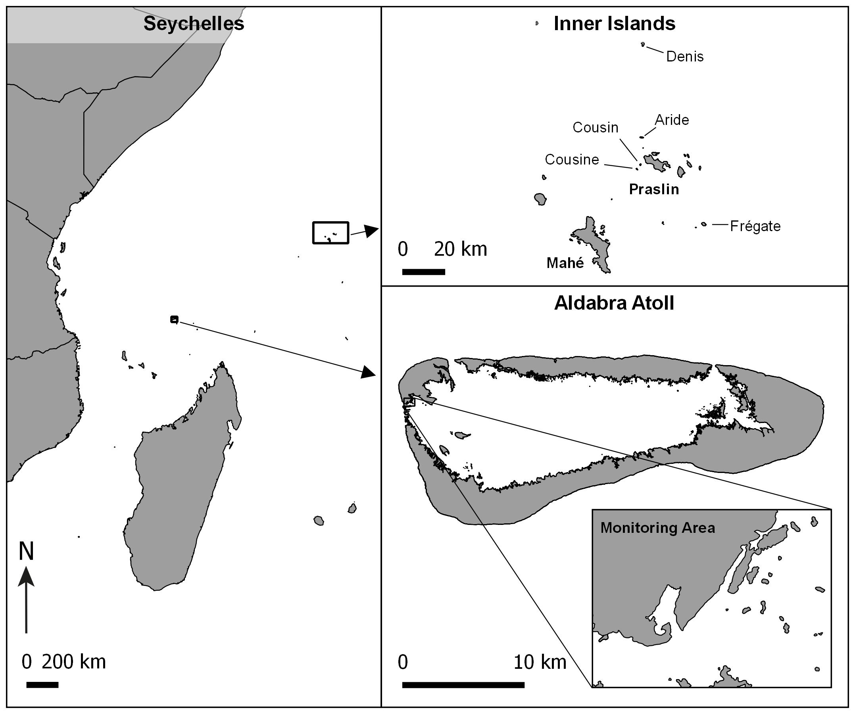
Figure 1: Map of Seychelles monitoring site locations

Table 1: Study site details
Site | Status | Species present | Methods | Data available
Aldabra | Special Reserve, UNESCO WHS | P. lepturus & P. rubricauda | Continuous year-round monitoring of specific area. | 2009–2016
Cousin | Special Reserve | P. lepturus | Once or twice a year random snapshot survey of approx. 100 nests. | 2005–2007, 2009–2016
Aride | Special Reserve | P. lepturus | Continuous year-round monitoring of specific area. | 2011–2016
Fregate | Privately Owned | P. lepturus | Continuous year-round monitoring of specific area. | Nov 2016–June 2017
Denis | Privately Owned | P. lepturus | Continuous year-round monitoring of specific area. | Nov 2015–Sept 2016
Cousine ?? | Privately Owned | P. lepturus | Fixed nest sites monitored weekly | 2007–2011

2.2. Collection of data

For all islands nesting tropicbirds were defined as an adult with an egg or a chick on a nest. To determine whether a nest was successful of not, we determined the stage at which it was last observed. If a nest was observed to be occupied by an egg or a partially feathered chick and it was subsequently observed empty or with signs of predation/death, we assumed nesting was unsuccessful. If, conversely, a nest was observed to be occupied by a fully feathered chick and in a posterior visit the nest was found to be empty and without signs of predation/death, we assumed that nesting was successful and therefore fledgling was likely to have occurred (hereafter nesting success). For all islands the stage of failure was also recorded (whether at egg, downy chick, partially feathered chick or fully feathered chick stage).
The methods of sampling nesting attempts do vary between the islands and therefore impacted the depth to which analysis was possible. The methods for each island are as follows:
2.2.1 Aldabra Atoll
Monitoring of 13 islets and an outcrop of Picard island have been monitored consistently every two weeks since 2009. This area is searched and all new nests are recorded and followed until failure of success is determined. The aim of the monitoring was to assess breeding success, breeding seasonality, nesting seasonality and frequency for both species of tropicbirds, with the additional aim of determining rates, stages and causes of nesting failure, particularly with regard to the effects of introduced rats.
2.2.2 Aride Island
Aride island follows a similar sampling method to Aldabra whereby a specific area of the island has been monitored consistently from 2011 to present with all new nests within that area being included and monitored closely. Monitoring frequency is once per week. The aim of the monitoring was to assess breeding success, nest density and seasonality over time
2.2.3 Cousin Island
Cousin Island has a long history of varying monitoring efforts but methods have been consistent since 2005 until present with just two years of missing data (2008 and 2012). The Cousin monitoring programme aims simply to establish an estimate of breeding success by sampling a certain number of nests (in most cases 100), not defined by area. Approximately 100 nests are selected when at the adult with egg stage and each attempt is followed until success or failure is determined, providing a snapshot of percentage breeding success. In most years this has taken place just once but in two occasions one survey was conducted in the wet season and one in the dry season.
2.2.4 Denis Island
The Denis island monitoring programme follows similar methods to that of Aride and Aldabra but was only established in November 2015 and due to staff constraints ended in August 2016, therefore data provides a monthly summary of new nests and nest outcomes but is insufficient to meet other aims at present.
2.2.5 Cousine Island
The methods used on Cousine Island are based on the monitoring of approximately 90 known nest sites continuously throughout the year. Therefore data provides a monthly summary of new nests and nest outcomes and the amount of new nests could be used as a proxy for nesting population trends.
2.2.6 Frégate Island
The Frégate Island monitoring programme follows similar methods to that of Aride, Denis and Aldabra but was only established in November 2016,

2.3. Data analysis

The disparity in data collection methods disallows direct comparison analysis between sites, as well as a variation in the depth of analysis possible.
2.3.1 Cousin
For Cousin island analysis is limited to a presentation of the mean breeding success and a simple linear regression of nesting success over time, this is due to limitations of the methods.
2.3.2 Denis & Frégate
For Denis, Cousine and Frégate the data sets are too short to do any temporal analysis and therefore simple mean nesting success is displayed.
2.3.3 Aride Island
For Aride, the continuous year-round and space-bound monitoring allows for analysis of temporal trends (Generalised Linear Model) and seasonality in both success (Not yet analysed) and nesting attempt abundance (Simple Linear Regression).
2.3.4 Cousine Island
For Aride, the continuous year-round and space-bound monitoring allows for analysis of temporal trends (Generalised Linear Model) and seasonality in both success (Not yet analysed) and nesting attempt abundance (Simple Linear Regression).
2.3.5Aldabra Atoll
Aldabra is the only island with both species present and monitored and therefore analysis is separated for both species and is analysed in-depth due to the data available. To determine the breeding periodicity (rhythmic patterns) of the focal species we used a wavelet analysis of the number of new nests per species. The wavelet decomposition identifies the dominant cycles in the time series. It quantifies the changes through time of the power of different periods, and therefore it also allows the detection of temporal changes on the periodicity. We evaluated the significance of the results produced by the wavelet analysis by comparing them to those produced by 99 randomisations of the time series.
Although the wavelet analysis provides an indication of the period, or duration, of the dominant cycles, it does not provide information on the timing of high and low seasons. To assess when the periods of peak and trough nesting activity occur, we used a series of generalised additive mixed effect models (GAMM) in which the response variable was, again, the total number of new nests established by each species in a monthly basis. In these models, we included date and month as smooth terms. Specifically, date was included to detect long term trends in nesting establishment, while month was included to account for the non-linear variation in nesting across the year. Finally, to account for differences in survey effort the number of surveys per month was also included as a linear predictor in these models.
Furthermore, we expect the seasonal and temporal patterns observed for nest establishment to be consistent with other indicators of nesting activity. Specifically, we examined the patterns of (i) the number of nests that were observed to be occupied by an egg or (ii) small chicks not yet feathered (‘C1’ chicks). These two additional variables were analysed in an identical fashion as the previously described models for nest establishment.
We then were interested on inspecting the temporal and spatial trends of nesting success and failure. Therefore, for each species, we constructed a series of GAMMs with a binomial error structure to model the probability (i) of nesting success, (ii) that nesting failed at egg stage, or (iii) that nesting failed at chick stage. In these models we included date as a smooth term to investigate temporal trends, while location was included as a factor to assess potential differences among islets and Picard. Competing models were assessed by comparing their Akaike information criterion (AICc).
Anecdotal evidence suggest that invasive rats might be a major predator of tropicbird eggs and chicks. As islets might be too small to sustain permanent rat populations, we therefore explored whether islet size, and distance from Picard (which is known to have resident rats) could explain the observed differences in nesting success. We accomplished this by including these two factors in a generalised linear model (GLM) in which the response variable was the probability of nesting success of each species. As in previous analysis, we chose the most parsimonious model by comparing their AIC.

3. Results

3.1. Overall Breeding Success
Average breeding success, expressed as a percentage of the total number of nests monitored, was lowest at Aldabra Atoll for WT tropicbirds, with even lower overall breeding success for RT tropicbirds, though Aldabra is the only site where nesting RTs are monitored and therefore there is comparison to be made for this species between sites. The Aride WTTB have the highest average breeding success (Denis island is excluded due to having less than a year of data available) followed by Cousin Island (Table 2).
Table 2: Average percentage breeding success, population estimates, potential predators and amount of data available for the 6 study sites.
Site | Mean Annual Breeding Success (SE) | Population estimates | Potential Predators/disruptive species | Number of years/months of data | Mean annual nests surveyed
Aldabra | WT: 15.26% (2.29)  RT: 11.24% (3.16) | Around 1800 nesting pairs for PR and 2000 pairs for PL (Diamond 1971) | Rattus rattus, Grey Heron, Aldabra Drongo. | 8y | WT:42  RT:84
Cousin | 33.20% (4.04) | 1,446 pairs in 2000 (Burger and Lawrence) | Egg predators:  Seychelles skink (Trachylepis seychellensis), Wright’s  skink (T. wrightii) and Seychelles Fody (Foudia sechellarum)  (Malan et al. 2009). Pisonia grandis | 10y | 100
Aride | 40.15% (3.84) | 2110 breeding pairs (Bowler et al. 2002) | Until recently Big-headed ants (Pheidole megacephala), Ticks, Pisonia grandis | 6y | 170
Frégate | 14% |  |  | 8m | 14 in eight months
Denis | 55% |  | None perceived, cats removed in 2000, rats removed in 2002 | 10m | 38 in ten months
Cousine | 51.6% |  | egg predators include the  Seychelles skink (Trachylepis seychellensis), Wright’s  skink (T. wrightii) and Seychelles Fody (Foudia sechellarum)  (Malan et al. 2009). Pisonia grandis | 5y | 107

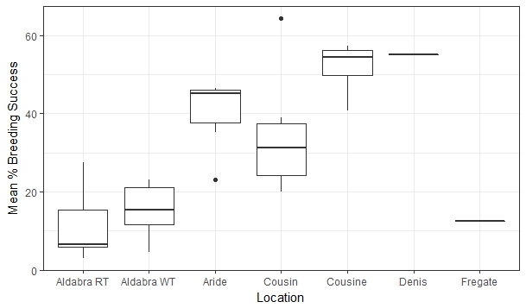
3.2 Aldabra Atoll
Surveys were consistently performed between 6 February 2009 and 4 November 2016 (Figure S1). In total 202 surveys were performed at a mean frequency of 2.3 ± 0.8 (mean ± standard deviation) per month. During these trips a total of 673 individual nests for P. rubricauda and 333 for P. lepturus were detected. Islet area ranged between 41 and 570 m² (mean 249 m²), while distance from Picard ranged between 14 and 464 m (mean 177 m).
Breeding seasonality
The wavelet analysis indicated an overall significant periodicity on the establishment of new nests by P. rubricauda but not for P. lepturus (Figure 2). For P. rubricauda the dominant cycle has a period of approximately 12 months, this is, peaks in nesting activity occur once a year. Nevertheless, the intensity of this yearly cycle has been damped to the point to which there has been no significant periodicity since late 2014.
The results of the wavelet analysis were strongly supported by those of the GAMMs, which indicated a significant effect of "month"" in the number of new nests established by P. rubricauda (p < 0.001; Figure 2A), with a peak in December and January, and a trough in June and July. As was expected, the number of nests occupied by downy chicks or eggs tracked the patterns shown by the number of established nests (Figure S2).
Furthermore, when exploring the long-term trends, a significant decrease was found in the number of new nests established by P. rubricauda over the monitoring period (p = < 0.001; Figure 3B). Contrastingly, for P. lepturus, neither the wavelet analysis nor the GAMMs showed evidence of a significant trend nor seasonal variation in the number of new nests nor the number of nest occupied by downy chicks or eggs (p = 0.33, p = 0.09, and p = 0.11 respectively; Figure 4).
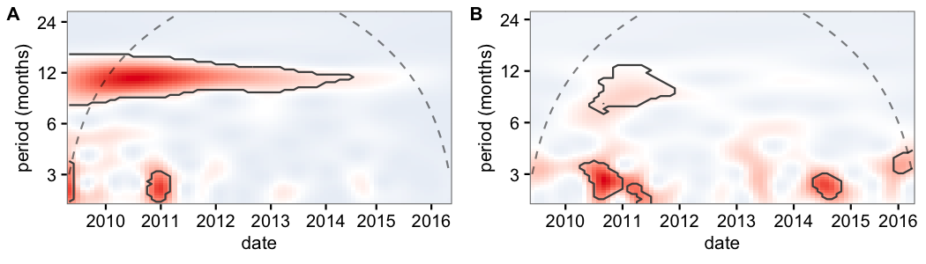
Figure 2: Wavelet decomposition of the number of new nests established by (A) P. rubricauda and (B) P. lepturus for the study period. The different colours indicate how the power of a particular month (y axis) changes during the study period (x axis). Shades of red indicate a higher power relative to blue shades. Dashed lines indicate the cone of influence, above which results should not be interpreted. The black contours indicate the regions in which periodicity was significantly different from the random expectation at the 0.05 level.
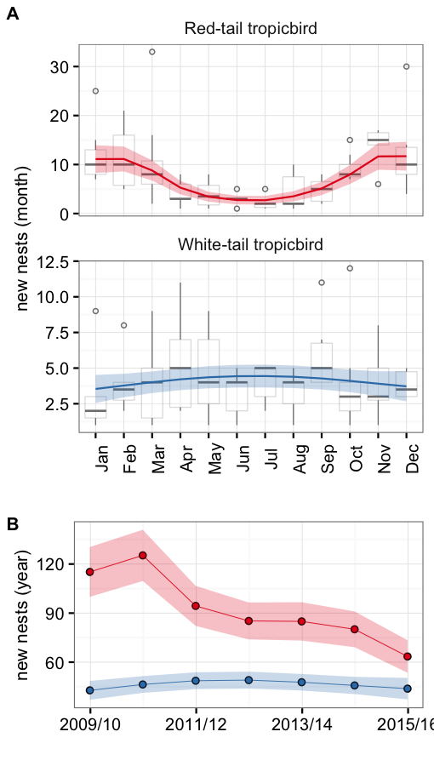
Figure 3: Number of new nests established by P. rubricauda (red) and P. lepturus (blue) a (A) monthly, and (B) yearly basis. Boxplots show the number of observed nests while lines and points depict the output of the most parsimonious models. The shaded areas indicate the corresponding standard error. All boxes cover the 25th–75th percentiles, the middle line marks the median, and the maximum length of the whiskers is 1.5 times the interquartile range. Points outside this range show up as outliers. Both the monthly and yearly trends were significant at the 0.05 level for P. rubricauda but not for P. lepturus. Results from the 2008/09 season were excluded due to incomplete sampling.
Breeding success
Overall, the outcome for 97% of the nests encountered was determined. On average 14% of nests were successful for both species, with most of the nests failing before the egg hatched (61% for P. rubricauda and 66% for P.lepturus; Figure 4A).
Based on terms retained by the final models (selected by AICc), we found evidence suggesting that the nesting success probability for P. rubrucauda varies significantly across time and space (Table S1). Across time, an overall downward trend was observed on the success probability characterised by peaks during 2010 and 2012 (Figure 4B). Consistent with this decrease in nesting success, we also detected a significant increase over time in the proportion of nests that failed before the egg hatched (Figure S3). Across space, we found that the nesting success on Picard was significantly larger when compared to other locations (Box S3, Figure S4).
Contrastingly, for P. lepturus we did not find evidence of any significant spatial trend. Furthermore, although date was maintained in the final model and suggests a decreasing trend, its magnitude is small and cannot be distinguished from random variation in the data at the 0.05 confidence level (Figure 4B, Table S2, Box S4).
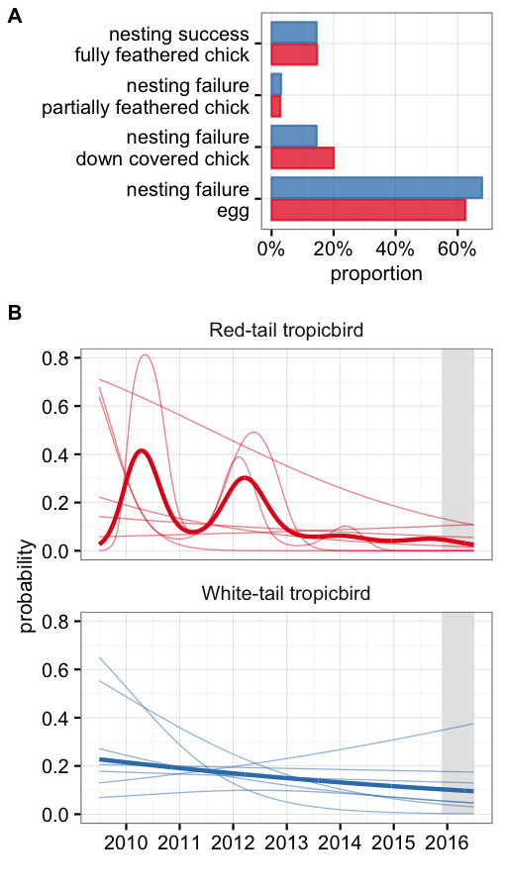
Figure 4: Nesting success for P. rubricauda (red) and P. lepturus (blue). (A) the overall proportion of stages for individual nests. (B) the modelled proabability of nesting success and failure (at the egg stage) over time. Solid lines indicate a significant effect at the 0.05 level.
When exploring the hypothesis that rat presence is the driver for the variability across locations it was found that, of the covariates of rat presence, there was only evidence of a significant positive relationship between islet area and nesting success for P. rubricauda (). The effect of this relationship was nevertheless small and corresponds to a difference of 10% increase in probability between the largest and the smallest islet. In addition, a negative relationship was found between the islet distance from Picard and the probability of failure (at egg stage, ) for P. lepturus. This corresponds to a 27% difference between the closest and furthest away islet. No relationship was found between the number of nests established in an islet and the success probability.

3.3 Aride Island
Surveys were consistently performed between 1 Jan 2011 and 31st Dec 2016. In total XXXX surveys were performed at a mean frequency of once per week. During these trips a total of 1033 nests were detected. The area surveyed is approximately XXXXha.
Modelling the nest success on yearly and monthly patterns with a GLM showed no significant trends in success with year (Figure 5, x²=0.12, df=1, P=0.7) but success varies significantly with month (x²= 76.64, df=11, P=>0.01). Specifically success is higher in February and lowest in April, May and July.
There is a strong negative trend in the number of new nests recorded annually (Figure 6) on Aride island (simple linear regression: F=59.74, df+4, P=>0.01).
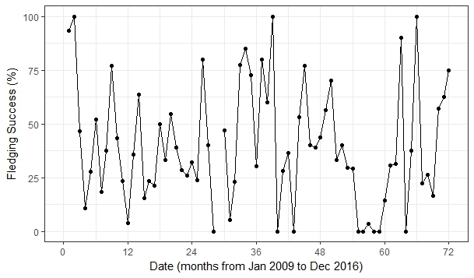
Figure 5: Monthly breeding success of P.lepturus on Aride island

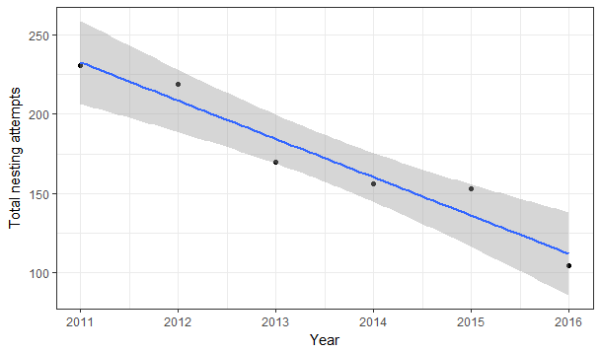
Figure 6: Linear regression of total new nests per year (blue line) fitted values and standard error of fitted values(grey area).

3.4 Cousin Island
Over a period of ten years breeding success averaged 33.20% (SE +/-4.04) and the annual breeding success shows no positive or negative trend over this time (Simple linear regression: F=4.16, df=8, P=0.07). From 2009 to 2016 failure at egg stage was the outcome for an average of 48% (SE=5) of the nesting attempts (ranging from 24% to 73%) and failure at chick stage accounted for an average of 27% (SE=9) of nesting attempts.

3.5 Denis Island
Over a period of ten months (Nov 2015 to Aug 2016) there were 39 nesting attempts recorded. Average monthly breeding success was 55% (SE=9.4). The outcome of 28% of these attempts was failure at egg stage, whilst 18% failed at chick stage. No trend or seasonality data can be garnered from this data.

3.6 Frégate Island
Over a period of eight months (Nov 2016 to June 2017) there were 16 nesting attempts recorded. total breeding success was 14%. No trend or seasonality data can be garnered from this data.

4. Discussion

Breeding success monitoring
In an effort to identify trends in breeding success and test the value of the data within a seabird hotspot region we combined monitoring efforts from six of the region's most vital nesting sites for tropicbirds. Tropicbird breeding success varied greatly between the sites. At Aldabra on average, for both species, 15% of nests were successful with most of the unsuccessful nests (70-75%) failing before hatching occurred. Breeding success was higher in the inner granitic islands where also a lower proportion of nesting attempts fail at egg stage. Previous studies indicate that breeding success of colonial seabirds is mainly influenced by climatic variations (Ancona et al., 2011), food availability (Hamer et al., 1993; Dearborn et al., 2001), introduction of exotic species (Russel and Le Corre, 2009) and intra/interspecific competition (Coulson, 2001; Dobson and Madeiros, 2010). These factors will vary greatly between sites and between regions though factors such as climatic variations and food availability would likely impact sites similarly within a certain range (For example between Aride, Cousin, Cousine and Fregate Islands). Tropicbirds specifically face a variety of potential nest predators as well as species which may interfere with adults nesting behavior, and these vary between the sites. On Cousin Island, Phillips (1985) found causes of nest failure to include heat stress (nest in direct sunlight causing adult to fly off and cool down resulting in egg failure), desertion (caused by some unknown stress of adult on nest), nest site competition (resulting in egg or small chick loss), predation by crabs (mostly small chicks)and skinks (mostly egg stage) and starvation in larger chicks. On Cousine island, Malan et al. (2003) found similar causes of nest failure with additional mention of egg predation from the Seychelles Fody Foudia sechellarum. Ramos et al (2005) described the additional impact of hard ticks on breeding success of WTTB on Aride island and more recently observation of big-headed ants infesting birds (pers.obs, Melinda Curran). At Aldabra Diamond (1975) stated that failures occurred due to intraspecific competition over nest sites, and possible impacts of the large Birgus latro crabs with no mention of the invasive predator Rattus rattus. Factors such as these (excepting those of introduced predators) establish a natural level of success for each site and if each factor maintains a constant then it is likely these natural levels of breeding success will not fluctuate greatly unless caused by some external factor, either directly (e.g climate patterns reduce food availability) or indirectly (e.g climate patterns reduce vegetation cover leading to less suitable nest conditions).
On Aldabra, Aride and Cousin nest success rates for WT have been stable over the study period but the success rate for RT (Aldabra only) has changed markedly over time. The highest rates for RT correspond to peaks reached during early 2010 and 2012, when 30-40% of established nests were successful. For most other years, the success rate varies between 5 and 10%. Based on this data alone, it is not possible to determine whether 2010 and 2012 are the norm, and therefore the low success rates observed between 2013 and 2016 represent a marked decline, or whether 2010 and 2012 were exceptionally good years and therefore low success rates are the norm for this species in Aldabra. But on average Aldabra has one of the lowest records of breeding success for both species throughout their ranges; RTTB breeding success was recorded as 46-80% in Western Australia (Tarburton 1977), 68 to 85% in Johnston Atoll (Schreiber, Doherty, and Schenk 2001), 76-88% (1991) in Christmass island (Schreiber 1994) and 59±4% (2006-2013) in O'Ahu, Hawaii (Vanderwerf and Young 2014). A stand-out study on Easter island (Flores et al, 2016) derived breeding success ranged of 37% in 2014 to 26% in 2015. Camera traps and direct observations showed interactions with five invasive alien species: the raptor (Milvago chimango) was the most severe predator of unattended eggs and chicks; cats were observed close to adult birds; dogs killed fledglings; ants preyed on newborn chicks; rats were recorded inspecting both occupied and unoccupied nests. It is remarkable that with five invasive predators the Easter island population still derives higher breeding success than Aldabra. During 1967-69 on Aldabra a study by Diamond derived a 4.4% success rate for one season and 44% success rate in the following season, showing the dramatic annual variation present for this species 50 years ago. Diamond attributed the extreme low breeding success to an unusually dry, calm and hot north-west monsoon season, stating that less vegetation cover than usual caused the RTTB to move off eggs to cool down, exposing eggs and small chicks to predators. The question whether rats impact the tropicbirds on Aldabra has long been hypothesised and determining this was an aim of the monitoring programme. A study of RTTB on Europa derived a breeding success of 2-8.5% (2008-2012) when rats where not controlled and 32% when rats were controlled on islets (Ringler, Russell, and Le Corre 2015) indicating the substantial impact that rats can have. When we compared success spatially, one big obstacle to the rat hypothesis was that for RTTB breeding success was highest on the mainland, not on the islets and that islet distance from Picard showed no effect on the success rate. Also that RTTB only are impacted indicates some species specific factor, while nesting success does not differ significantly for WT among locations, it does for RT indicating some potential influence of nest site choice. The interaction between nesting site quality/availability and species' preferences may affect the nests' vulnerability to rats (or other predators), and therefore explain the observed differences across locations. Nest site is an important factor governing nest success, avoiding excessive cold and hot temperatures are essential for egg development stage as these can slow development and cause embryonic death (Grant 1982; Olson et al. 2006) and tropical seabird species have a more delayed onset of thermoregulatory capabilities when compared with those in temperate environments; therefore nest microhabitats and behavioural thermoregulation, are important factors during egg brooding and early chick development (Hart et al, 2017). Indeed, nest site choice could therefore negate some effects of environmental stressors with some habitats providing suitable nest microclimates (Hart et al, 2016). The current monitoring programme was inadequate to include nest site parameters into the analysis and will therefore be revised.

WTTB breeding success appears to be stable across the sites with Cousin averaging 33% compared to the 36% recorded by Phillips in 1985, Aride averaging 40% compared to the 21-37% recorded by Ramos et al. in 2005.INCLUDE COUSINE IF THEY SUPPLY DATA (25% Malan, 2005) Aldabra again is the site showing a marked difference in breeding success for WTTB between the studies, with 15% compared to 47.5% recorded by Diamond (1975). Within a global setting the Aldabra breeding success is similar to that found at Fernando de Noronha archipelago where 14.3% of nesting attempts are successful and predation at egg stage account for 50% of the attempts. Europa supports even lower nesting success with 6.9% for non rats controlled habitats (Ringler, Russell, and Le Corre 2015). Elsewhere breeding success is more aligned with that found in the inner grantic Seychelles; 30% in Ascension Island (Stonehouse 1962), 21% Cayo Luis Peia, Puerto Rico (Schaffner 1991).
At Aldabra the abundance of RT nests shows a negative trend and has been in constant decline since 2010. Contrastingly the abundance of WT nests has been stable and does not show any significant temporal trend. The Aride island WT population nest abundance showed a continuous negative trend since 2011. The other islands data was either not enough to establish trends or the methods do not include nesting abundance as a factor. This is the first data that suggest population decline for RTTB at Aldabra, and indeed for the region, whereas the WTTB population decline on Aride was previously established, though our data supports that the population continues to decline. Bowler et al. (2002) showed that the WTTB on Aride suffered an apparent decline of 60% between 1989 and 1998. Although the main causes for this decrease was not identified at the time, additional work by Catry et al (2009) determined that annual adult survival could not be linked to inter-annual variability in oceanographic conditions, but may be more influenced by Pisonia fruiting events, which, overall, accounts for 23.2% of the adult mortality (Pisonia grandis produces sticky seeds which trap and kill seabirds). Based on survival rates they predicted that the probability of extinction of this population would be 99% in 170 years and suggested some active management by maintaining some open areas both at canopy and ground level. Despite Ramos et al. (2005) finding that breeding success for WT on Aride was significantly correlated with the El Nin˜o Multivariate Index there was little evidence that productivity was influenced by local factors in general. There are two key factors that suggest population decline on Aride is caused by adult survival at the site; firstly that Aride island continues to maintain relatively high and stable breeding success for WTTB and secondly that neighbouring island Cousin maintains stable population trends (1987 to 2014, unpublished data).

Monitoring Programmes
Monitoring species is a critical part of effective conservation, but many species are being monitored without a clear understanding of how the information derived from the monitoring will help to conserve the species. The measure of breeding success alone does not sufficiently tell us the status of a species, as seen on Aride a species may maintain stable breeding success yet experience a decline in population. To assess species health, monitoring should also include a measure of abundance, a measure of breeding patterns and record the detail of nest stage failures. We therefore propose all sites to identify an area suitable for frequent monitoring (large enough to be representative of the variety in breeding sites available and to include a decent sized sample of nesting attempts) and to monitor this area in a continuous long-term monitoring programme, to capture all new nesting attempts and record the outcomes of each.
To use tropicbirds as indicators of the surrounding ocean health we need to be able to separate the factors influencing breeding success, accounting for as many intrinsic (predation, nest site choice, competition) factors as possible as part of the monitoring programme to rule out site specific impacts, allowing the influence of extrinsic factors (food availability, climate) to be determined. We therefore propose that monitoring programmes should include some measure of nest site choice, both habitat type and exposure level, to assess this factors influence on nesting success at all sites in the future. Monitoring should focus on data quality not quantity and therefore regular nest searches and checks in a smaller area are preferable to less frequent checks covering a broader expanse. A detailed methods protocol should be available at all sites to ensure that methods are consistent over time. Additional studies may also be incorporated depending on time and resources available; these include: mark and recapture data, adding adult survival as a potential factor; predator presence and impacts via the use of camera traps; adult incubation behaviour and feeding frequency can also be determined using camera traps.
Many of the factors influencing breeding success at a site level could be incorporated into an ecosystem monitoring approach, using a selection of environmental conditions and ecological components that could then be used in future analysis, for example, weather data, vegetation and predator abundance.
Streamline monitoring programmes
This study highlight that great amounts of data are being collected across the Seychelles, although there is some disparity between methods and that the data is not being fully utilised, at least not frequently enough, or at a high enough level to fulfil the true value of such data within a conservation management context. We propose a Seychelles wide monitoring protocol be developed, inclusive of a standardised database which can be used by all islands within this study and others which may also develop seabird monitoring programmes. This will enable direct comparability between sites at a level which will enable Tropicbirds to be used as indicators of ocean health and therefore directly feed into conservation management strategies within the region.

5. Conclusions

The Western Indian Ocean has recently been identified as a key area to prioritize for the conservation of global marine biodiversity in the face of climate change (Ramírez et al. 2017). The Seychelles Archipelago supports the greatest abundance of seabirds in the tropical Indian
Ocean with 14 breeding species totaling 2.2 million pairs (Le Corre et al, 2012). Regional seabird population success and trend data is not readily available despite data being collected for many years at several locations. A greater effort must be made to streamline regional data and utilise the results to steer management practices and channel research resources towards the most critical areas.

Acknowledgements

The authors would like to thank .....

References

Bowler, J., M. Betts, I. Bullock and J. A. Ramos. 2002. Trends in Seabird numbers on Aride Island Nature Reserve, Seychelles 1988-2000. Waterbirds 25: 26-38.
Bailey, R S. 1968. “The pelagic distribution of sea-birds in the western Indian Ocean.” Ibis 110 (4): 493–519. doi:10.1111/j.1474-919X.1968.tb00060.x.
Benson, C W. 1967. “The birds of Aldabra and their status,” no. 234: 1–674. papers2://publication/uuid/BEA3F4A8-A770-4CE8-BAE3-E04149760516.
Burger, Joanna, and Michael Cochfeld. 1991. “Nest-Site Selection by the Herald Petrel and White-Tailed Tropicbird on Round Island, Indian Ocean” 103 (1): 126–30.
Burger AE, Lawrence AD (2000) Seabird monitoring handbook for Seychelles: suggested methods for censusing seabirds and monitoring their breeding performance. Birdlife Seychelles, Mahe´, Seychelles
Castillo-Guerrero, Ja, Ma Guevara-Medina, and Eric Mellink. 2011. “Breeding ecology of the Red-billed tropicbird Phaethon aethereus under contrasting environmental conditions in the Gulf of California.” Ardea 99 (1): 61–71. doi:10.5253/078.099.0108.
Catry, Demography and conservation of the White-tailed TropicbirdPhaethon lepturus on Aride Island, Western Indian Ocean
Catry, Teresa, Jaime A. Ramos, Inês Catry, David Monticelli, and José P. Granadeiro. 2013. “Inter-annual variability in the breeding performance of six tropical seabird species: Influence of life-history traits and relationship with oceanographic parameters.” Marine Biology 160 (5): 1189–1201. doi:10.1007/s00227-013-2171-2.
Catry, Teresa, Jaime A. Ramos, Sébastien Jaquemet, Lucie Faulquier, Maud Berlincourt, Antoine Hauselmann, Patrick Pinet, and Matthieu Le Corre. 2009. “Comparative foraging ecology of a tropical seabird community of the Seychelles, western Indian Ocean.” Marine Ecology Progress Series 374: 259–72. doi:10.3354/meps07713.
Clark, Author L, R E Ricklefs, R W Schreiber, Source The Auk, No Oct, L Clark, R E Ricklefs, and R W Schreiber. 1983. “Nest-Site Selection by the Red-Tailed Tropicbird” 100 (4): 953–59.
Clark, Larry, Ralph W. Schreiber, and Elizabeth A. Schreiber. 1990. “Pre- and post-El Niño Southern Oscillation comparison of nest sites for Red-Tailed Tropicbirds breeding in the central Pacific Ocean.” The Condor 92 (4): 886–96. doi:10.2307/1368724.
Corre, Matthieu Le. 2001. “Breeding seasons of seabirds at Europa Island (southern Mozambique Channel) in relation to seasonal changes in the marine environment.” Journal of Zoology 254: 239–49. doi:10.1017/S0952836901000759.
Diamond, A W. 1971. “The Ecology of the Sea Birds of Aldabra” 260 (836): 561–71.

Diamond, A W.. 1975. “The Biology of Tropicbirds at Aldabra Atoll , Indian Ocean” 92 (1): 16– 39.
Dunlop, C L, and R D Wooller. 1986. “Range extensions and the breeding seasons of seabirds in south-western Australia.” Records of the Western Australia Museum 12 (4): 389–94.
Dunlop, J. N., C. A. Surman, and R. D. Wooller. 2001. “The marine distribution of seabirds from Christmas Island, Indian Ocean.” Emu 101 (1): 19–24. doi:10.1071/MU00060.
Feare, Christopher J. 1981. “Breeding Schedules And Feeding Strategies Of Seychelles Seabirds.” doi:10.1080/00306525.1981.9633603.
Fleet, R.R. 1972. “Nesting success of the Red-Tailed Tropicbird on Kure Atoll.” The Auk 89 (3): 651–59.
Fleet, R.R.. 1974. “The Red-Tailed Tropicbird on Kure Atoll,” no. 16: 1–64.
Haney, J. C., and A. E. Stone. 1988. “Seabird foraging tactics and water clarity: are plunge divers really in the clear?” Marine Ecology Progress Series 49 (1-2): 1–9. doi:10.3354/meps049001.
Hart, Lorinda A., Colleen T. Downs, and M. Brown. 2016a. “Hot footing eggs: thermal imaging reveals foot mediated incubation in White-tailed Tropicbirds, Phaethon lepturus.” Journal of Ornithology 157 (2). Springer Berlin Heidelberg: 635–40. doi:10.1007/s10336-015-1323-1.
Hart, Lorinda A., Colleen T. Downs, and Mark Brown. 2016b. “Sitting in the sun: nest microhabitat affects incubation temperatures in seabirds.” Journal of Thermal Biology 60. Elsevier: 149–54. doi:10.1016/j.jtherbio.2016.07.001.
Hart, Lorinda A.Keeping it regular: Development of thermoregulation in four tropical
seabird species
Howell, Thomas R, and George A Bartholomew. 1962. “Temperature regulation in the red-tailed tropic bird and the red-footed booby” 68 (2): 113–51.
Le Corre, M, Y Cherel, F Lagarde, H Lorme, and P Jouventin. 2003. “Seasonal and inter-annual variation in the feeding ecology of a tropical oceanic seabird, the redtailed tropicbird Phaeton rubricauda.” Marine Ecology Progress Series 255: 289–301.
Leal, G R, P P Serafini, R J Ladle, and M A Efe. 2016. “Breeding of White-tailed Tropicbirds ( Phaethon lepturus ) in the western South Atlantic” 76 (3): 559–67.
Le Corre: Tracking seabirds to identify potential Marine Protected Areas in the tropical western Indian Ocean
Malan, G., D. Hagens, and Q. Hagens. 2010. “Nesting success of White Terns and White-tailed Tropicbirds on Cousine Island, Seychelles.” Ostrich 80 (2): 81–84. doi:10.2989/OSTRICH.2009.80.2.3.830.
Morrell, Thomas E, Steven M Aquilani, Thomas E Morrell, and Steven M Aquilani. 2000. “Nest-Site Characteristics of Red-Tailed Tropicbirds on Rose Atoll , American Samoa” 71 (3): 455–59.
Navarro, Joan, Rocio Moreno, Lena Braun, Carola Sanpera, and Janos C Hennicke. 2014. “Resource partitioning between incubating and chick-rearing brown boobies and red- tailed tropicbirds on Christmas Island.” Zoological Studies 53 (1): 27. doi:10.1186/s40555-014-0027-1.
Pennycuick, C J, F C Schaffner, M R Fuller, I I I Obrecht H H, and L Sternberg. 1990. “Foraging flights of the white-tailed tropicbird (Phaethon lepturus): radiotracking and doubly- labelled water.” Colonial Waterbirds 13 (2): 96–102.
Phillips, Nj. 1987. “The breeding biology of White-tailed Tropicbirds Phaethon lepturus at Cousin Island, Seychelles.” Ibis 129 (January 1983): 10–24. doi:10.1111/j.1474- 919X.1987.tb03156.x.
Prys-Jones, R. P., and C. Peet. 1980. “Breeding periodicity, nesting success and nest site selection among red-tailed tropicbirds Phaethon rubricauda and white-tailed tropicbirds P. lepturus on Aldabra Atoll.” Ibis 122 (1): 76–81. doi:10.1111/j.1474- 919X.1980.tb00873.x.
Ramos, Jaime A., and Carlos Pacheco. 2003. “Chick growth and provisioning of surviving and nonsurviving white-tailed tropicbirds (Phaethon lepturus).” The Wilson Bulletin 115 (4): 414–22. doi:10.1676/03-052.
Ramos, Jaime A., John Bowler, Michael Betts, Carlos Pacheco, Jamie Agombar, Ian Bullock, and David Monticelli. 2005. “Habitat Use of the Black-faced Spoonbill.” Waterbirds 27 (1998): 129–34.
Ramos JA, Bowler J, Betts M, Pacheco C, Agombar J, Bullock I, Monticelli D. 2005. Productivity of White-tailed Tropicbird on Aride Island, Seychelles. Waterbirds 28: 405– 542.
F. Ramírez, I. Afán, L. S. Davis, A. Chiaradia, Climate impacts on global hot spots of
marine biodiversity. Sci. Adv. 3, e1601198 (2017).
Ringler, David, James C. Russell, and Matthieu Le Corre. 2015. “Trophic roles of black rats and seabird impacts on tropical islands: Mesopredator release or hyperpredation?” Biological Conservation 185. Elsevier Ltd: 75–84. doi:10.1016/j.biocon.2014.12.014.
Schaffner, Fred Charles. 1991. “Nest-Site Selection and Nesting Success of White-Tailed Tropicbirds ( Phaethon lepturus )” 108 (4): 911–22.
Schreiber, Elizabeth A. 1994. “El Nino-Southern Oscillation Effects on Provisioning” 17 (2): 105–19.
Schreiber, Elizabeth A, Paul F Doherty, and Gary A Schenk. 2001. “Effects of a Chemical Weapons Incineration Plant on Red-Tailed Tropicbirds” 65 (4): 685–95.
Schreiber, Ralph W, and Philip N Asmole. 1970. “Seabird Breeding Seasons on Christmas Island, Pacific Ocean.” Journal of Chemical Information and Modeling 53 (49): 1689–99. doi:10.1017/CBO9781107415324.004.
Stonehouse, Bernard. 1962. “The Tropic Birds (Genusphaethon) Of Ascension Island.” Ibis 103B (2): 124–61. doi:10.1111/j.1474-919X.1962.tb07242.x.
Tarburton, MK. 1977. “Nesting of the Red-tailed Tropicbird at Sugarloaf Rock, WA.” Emu 77 (3): 122. doi:10.1071/MU9770122.
Vanderwerf, Eric A., and Lindsay C. Young. 2014. “Breeding biology of Red-tailed Tropicbirds Phaethon Rubricauda and response to predator control on O’Ahu, Hawai’I.” Marine Ornithology 42 (1): 69–72.
Veitch, C R, C Gaskin, K Baird, and S M H Ismar. 2011. “Changes in bird numbers on Raoul Island , Kermadec Islands , New Zealand , following the eradication of goats , rats , and cats.” Island Invasives: Eradication and Management, no. February 2010: 372–76.
Whittow, G. C. 1980. “Physiological and ecological correlates of prolonged incubation in sea birds.” Integrative and Comparative Biology 20 (2): 427–36. doi:10.1093/icb/20.2.427

